CSV Management Functional Requirements

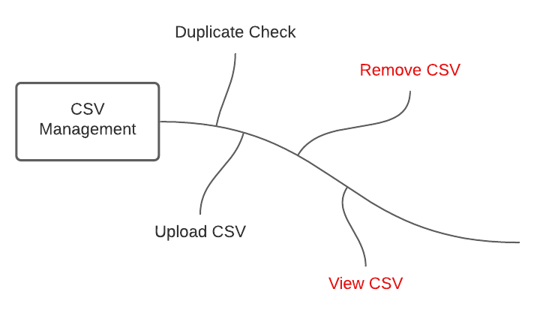

# Functional Requirements

1. Admins shall be able to upload the yearly CSV health indicators to the system.
2. The CSV Management System shall check if the user is uploading a duplicate CSV.
3. The CSV Management System shall get the year of the CSV being uploaded.
4. The CSV Management system shall save the original CSV in a separate location than the altered CSV.
5. After uploading the CSV, the system shall remove the first row of the CSV.